Topic No. | Name of Topic | Summer-25 |  | Winter-25
 |  | Question | Marks | Question | Marks
1 | Fundamentals of Data Communication and Computer Network | 1 (a)  1 (b)  1 (c) | 2  2  2 | 1 (a)  1 (b)  2 (a) | 2  2  4
 |  | 1 (g) | 2 | 3 (b) | 4
 |  | 2 (a) | 4 | 4 (b) | 4
 |  | 3 (a) | 4 | 5 (c) | 6
 |  | 4 (a) | 4
 |  | 5 (a) | 6
 |  |  | 26 |  | 22
 | Transmission Media And Switching | 4 (b) | 4 | 1 (c) | 2
2 |  | 5 (b)  6 (a) | 6  6 | 2 (b)  4 (a) | 4  4
 |  |  |  | 5 (a) | 6
 |  |  |  | 6 (a) | 6
 |  | Total | 16 |  | 22
3 | Error Detection and Correction | 1 (d)  2 (b)  3 (b)  4 (c)  6 (b) | 2  4  4  4  6 | 1 (d)  1 (e)  4 (c)  5 (b) | 2  2  4  6
 |  | Total | 20 |  | 14
 | Network Communication Models | 1 (e) | 2  2  4  4  4  4  4  4  6 | 1 (g)  2 (c)  2 (d)  3 (a)  3 (d)  4 (d)  6 (c) | 2  4  4  4  4  4  6
 |  | 1 (f)
4
 |  | 2 (c)
 |  | 2 (d)
 |  | 3 (c)
 |  | 3 (d)
 |  | 4 (d)
 |  | 4 (e)
 |  | 5 (c)
 |  | Total | 34 |  | 28

5 | Network Topologies And Network Devices | 6 (c) | 6 | 1 (f)  3 (c) | 2  4
 |  |  |  | 4 (e) | 4
 |  |  |  | 6 (b) | 6
 |  | Total | 06 |  | 16

Exam Year | Unit No and Name | Question no as per MSBTE paper | Marks
Summer- 2025 | Unit 1 | Q1a. Enlist four basic characteristics for efficient data communication system. Ans.  Delivery – Data must reach the correct destination Accuracy – Data should be free from errors Timeliness – Data must be delivered on time  Jitter – Variation in packet arrival time should be minimum  Q1b. The bit rate of a signal is 2000. If each signal element carries five bits. What is the baud rate? Ans.  Baud Rate = Bit Rate/ Bits per symbol  2000/5 = 400 baud  Q1c. State four disadvantages of line of sight Transmission (LOS) with respect to Data Communication. Ans.  Obstruction affects communication Limited distance coverage Affected by weather conditions  Requires proper alignment of antennas  Q1g. State four requirements of Network computing Model to share resources and information. Ans.  The four requirements of a Network Computing Model to share resources and information are:  - Connectivity:  All computers and devices must be interconnected through reliable communication links.  - Communication Protocols:  Standard protocols are required to ensure proper data exchange between different systems.  - Resource Sharing Mechanism:  The network should support sharing of hardware (printers, storage) and software resources.  - Security:  Proper authentication and access control mechanisms are required to protect shared data and resources.  Q2a. Give difference between Analog Signal and Digital Signal with respect to terms.  - Representation/Diagram ii) Bandwidth iii) Data Storage iv) Application/uses Ans. | 2  2  2  2  4

 |  |  |  |  |  | 4
 |  | Parameter | Analog Signal | Digital Signal
 |  | i) Representation / Diagram | Continuous waveform (sine wave) with infinite values | Discrete waveform (square wave) with binary values 0 and 1
 |  | ii) Bandwidth | Requires comparatively less bandwidth | Requires more bandwidth
 |  | iii) Data Storage | Difficult to store; quality degrades over time | Easy to store; no loss of quality
 |  | iv) Applications / Uses | Radio broadcasting, telephone, audio systems | Computers, mobile communication, digital networks
Q3a. Explain the terms related to Bandwidth in Data communication and networking. i) Amplitude with diagram and units used to measure amplitude. ii) Frequency with diagram and units used to measure frequency. iii) Wavelength with diagram and formula used to calculate wavelength. iv) Phase with diagram and units used to measure phase.
Ans.
- Amplitude
Amplitude represents the strength or height of a signal. It indicates the maximum value of the signal from its mean (zero) level. Higher amplitude means stronger signal power.

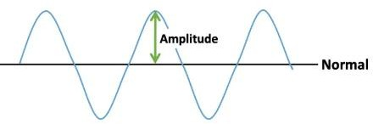

Unit:
  - Volt (V)
  - Decibel (dB)
- Frequency
Frequency is the number of complete signal cycles occurring in one second. It determines how fast the signal changes.

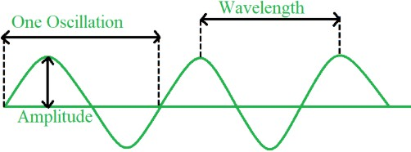
Unit:
- Hertz (Hz)

- Wavelength
Wavelength is the physical distance between two successive points of a wave, such as two consecutive peaks or troughs. Diagram
A sine wave showing the distance between two consecutive peaks.

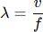

Where:
  - 𝜆= Wavelength (meters)
  - 𝑣= Velocity of signal (m/s)
  - 𝑓= Frequency (Hz)

Unit:
  - Meter (m)

- Phase
Phase indicates the position of a signal waveform relative to a reference point or another signal. It shows how much a wave is shifted in time.

 |  | 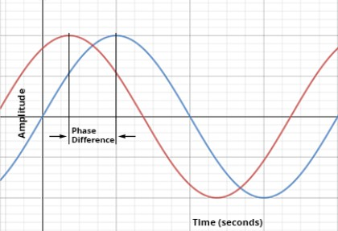  Unit:  - Degree (°)  - Radian (rad)  Q4a. Explain Full Duplex Communication Mode with neat labelled diagram for Data Communication. State two advantages of Full Duplex Communication. State two disadvantages of Full Duplex Communication.  Ans. Explanation:  Full duplex communication is a mode of data transmission in which both sender and receiver can transmit and receive data simultaneously. There is no need to wait for the other device to finish transmitting, as communication occurs in both directions at the same time.  This mode provides faster and more efficient communication and is commonly used in telephone systems, mobile communication, and computer networks.  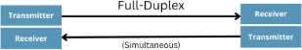  Advantages of Full Duplex Communication:  - High data transmission speed due to simultaneous communication.  - No delay or waiting time, as both devices communicate at the same time. Disadvantages of Full Duplex Communication:  - Costly hardware is required to support simultaneous transmission.  - Complex system design compared to simplex and half duplex modes.  Q5a. Explain the following types of network with neat label diagram.  - LAN  - MAN | 4  6

iii) WAN
Ans.
- Local Area Network (LAN) Explanation:
A Local Area Network (LAN) is a network that connects computers and devices within a limited geographical area such as a room, building, office, or campus. LAN provides high data transfer speed and is generally owned and managed by a single organization.
Examples:
  - Office network
  - College computer laboratory

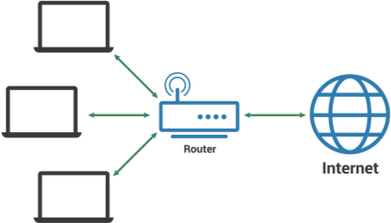

- Metropolitan Area Network (MAN) Explanation:
A Metropolitan Area Network (MAN) covers a larger area than LAN but smaller than WAN, typically a city or town. MAN interconnects multiple LANs using high-speed communication links like optical fiber.
Examples:
  - City-wide cable TV network
  - Government networks in a city

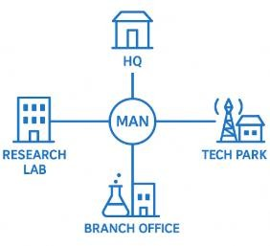

Wide Area Network (WAN) Explanation:
A Wide Area Network (WAN) spans a very large geographical area, such as a country or the entire world. WAN connects multiple LANs and MANs using public communication networks like satellite, leased lines, or the Internet.
Examples:
- Internet
- Bank networks

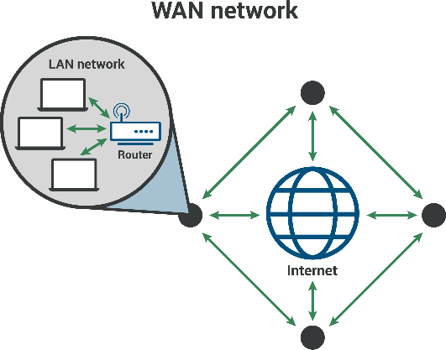

Winter- 2025 | Unit 1 | Q1a. Define computer network and state its types. Ans.  A computer network is a system in which two or more computers and devices are connected together using communication media so they can share data, resources, and services such as files, printers, internet connections, and applications.  A network enables communication between devices through wired or wireless technologies using protocols. Types:  LAN – Local Area Network  MAN - Metropolitan Area Network WAN - Wide Area Network | 2
 |  | Q1b. Define bit rate and baud rate. Ans.  Bit rate is the number of bits transmitted per second in a communication channel. It measures how fast data is transmitted. | 2
Baud rate is the number of signal units (symbols) transmitted per second.
A symbol may represent one or more bits, depending on the modulation technique.
 |  | Q2a. Explain components of data communication in brief  A data communication system has five essential components: | 4

 |  | 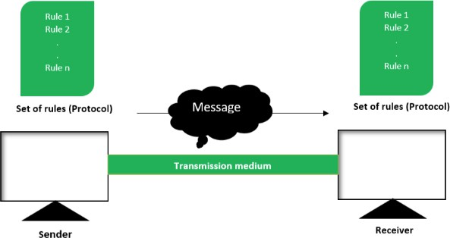  Sender (Source)  - The device that originates the message.  - Examples: Computer, mobile phone, workstation. Receiver (Destination)  - The device that receives and interprets the message.  - Examples: Another computer, printer, server.  Message  - The data or information to be communicated.  - Examples: Text, audio, video, images, files.  Medium (Transmission Channel)  - The physical path through which the message travels.  - Examples: Twisted pair cable, fiber optic cable, radio waves, satellite links.  Protocol  - A set of rules that govern data communication.  - Ensures reliable and error-free data transfer.  - Examples: TCP/IP, HTTP, FTP, SMTP.  Q3b. Describe modes of communication. Ans.  In data communication, the mode of communication defines the direction of data flow between two communicating devices. There are three main modes of communication:  - Simplex Mode  - Communication occurs in only one direction.  - One device acts as a sender and the other as a receiver.  - The receiver cannot send data back. Examples:  - Keyboard → Computer | 4

 |  | - Television broadcast  - Radio transmission Diagram (conceptual):  Sender ➝ Receiver  - Half Duplex Mode  - Communication occurs in both directions, but not at the same time.  - Devices take turns to send and receive data. Examples:  - Walkie-talkie  - CB radio communication Diagram (conceptual):  Device A ⇄ Device B (one direction at a time)  - Full Duplex Mode  - Communication occurs in both directions simultaneously.  - Both devices can send and receive data at the same time. Examples:  - Telephone conversation  - Video conferencing  - Modern computer networks Diagram (conceptual):  Device A ⇄ Device B (simultaneous communication)  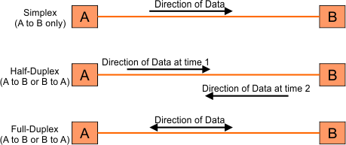  Q4b. Compare analog signal and digital signal. |  |  |  | 4
 |  | Parameter | Analog Signal | Digital Signal
 |  | Nature of signal | Continuous signal | Discrete signal
 |  | Signal values | Takes infinite values within a range | Takes only two values (0 and 1)
 |  | Representation | Smooth waveform (sine wave) | Square or rectangular waveform

 |  | Noise immunity |  | More affected by noise and interference |  | Less affected by noise |  |  | 6
 |  | Accuracy |  | Less accurate due to noise |  | More accurate and reliable
 |  | Error detection |  | Difficult to detect and correct errors |  | Easy to detect and correct errors
 |  | Bandwidth requirement |  | Generally lower |  | Generally higher
 |  | Examples |  | Human voice, analog radio |  | Computer data, digital telephony
 |  | Q5c. Compare between LAN, WAN and MAN
 |  | Parameter | LAN (Local Area Network) |  | MAN (Metropolitan Area Network) |  | WAN (Wide Area Network)
 |  | Area covered | Small area such as room, building, or campus |  | Covers a city or metropolitan area |  | Covers large geographical areas (country or world)
 |  | Ownership | Usually owned by a single organization |  | Owned by government or large organizations |  | Owned by multiple organizations or service providers
 |  | Data transfer speed | Very high |  | High |  | Comparatively lower
 |  | Cost | Low installation and maintenance cost |  | Moderate cost |  | High cost
 |  | Transmission media | Twisted pair, coaxial, optical fiber |  | Optical fiber, microwave |  | Optical fiber, satellite, leased lines
 |  | Error rate | Very low |  | Low |  | Higher compared to LAN and MAN
 |  | Examples | College network, office network |  | City cable TV network, Metro Ethernet |  | Internet, bank networks
Summer- 2025 | Unit 2 | Q4b. Explain the working of satellite communication system in detail with signal uplink and signal downlink along with neat labelled diagram.  Ans.  Satellite communication is a wireless communication system in which an artificial satellite is used as a relay station between two or more earth stations. It enables long-distance communication over large geographical areas, including remote locations.  A satellite communication system mainly works using two signals:  - Uplink  - Downlink  Working of Satellite Communication System  - Uplink:  - The transmitting earth station sends the signal to the satellite.  - This signal travels from Earth to the satellite at a higher frequency to avoid interference.  - The uplink signal is received by the satellite’s antenna.  - Satellite Transponder: |  |  |  |  |  |  | 4

 |  | - The satellite contains a transponder which receives the uplink signal.  - The transponder amplifies, filters, and changes the frequency of the signal to avoid interference with uplink signals.  - Downlink:  - The processed signal is transmitted back from the satellite to the receiving earth station.  - Downlink uses a lower frequency than uplink.  - The receiving earth station decodes the signal to retrieve the original data.  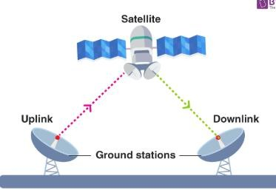  Types of Satellites  - LEO – Low Earth Orbit  - Orbit height: 500 to 2,000 km  - Low signal delay  - Used in mobile communication and GPS  - Requires many satellites for full coverage  - MEO – Medium Earth Orbit  - Orbit height: 2,000 to 20,000 km  - Moderate delay  - Used in navigation systems like GPS  - GEO – Geostationary Earth Orbit  - Orbit height: 35,786 km  - Appears stationary relative to Earth  - Covers large area with fewer satellites  - Used in TV broadcasting and weather monitoring  Q5b. Explain three phases of connection oriented packet switching with neat labelled sketch. State two advantages of packet switching. State two disadvantages of packet switching  Ans. | 6

Connection oriented packet switching is a communication technique in which a logical path (virtual circuit) is established between sender and receiver before data transmission begins. Data packets follow the same predefined path during communication.

Three Phases of Connection Oriented Packet Switching
- Connection Establishment Phase
  - Before transmitting data, a connection is established between the source and destination.
  - Routing information and resources are reserved.
  - Both sender and receiver agree on communication parameters.

- Data Transfer Phase
  - Data is divided into packets.
  - All packets are transmitted through the same established path.
  - Packets arrive in sequence at the destination.

- Connection Termination Phase
  - After data transmission is complete, the connection is released.
  - Network resources are freed.
  - Communication session ends.

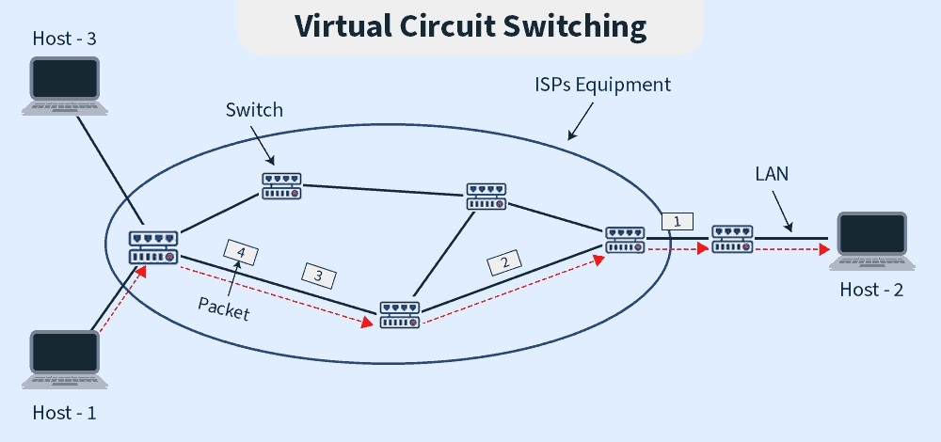

Advantages of Packet Switching
- Efficient utilization of network bandwidth.
- Reliable data transmission due to error control and routing.

Disadvantages of Packet Switching
- Packet delay and jitter may occur.

 |  | 2. Packet loss or out-of-order delivery is possible.  Q6a. Define Time Division Multiplexing (TPM) Explain two types of Time Division Multiplexing with neat sketch. State two applications of TDM.  Ans.  Time Division Multiplexing (TDM) is a multiplexing technique in which multiple signals share the same communication channel by dividing the total transmission time into different time slots. Each signal is transmitted one at a time in its assigned time slot.  Types of Time Division Multiplexing  - Synchronous Time Division Multiplexing  - Time is divided into fixed time slots.  - Each sender is assigned a specific time slot whether it has data or not.  - If a sender has no data, its time slot remains unused.  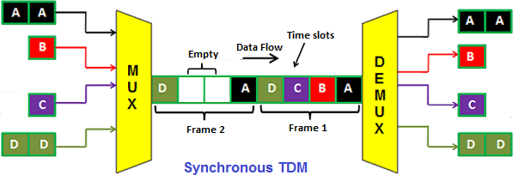  - Statistical Time Division Multiplexing  - Time slots are assigned dynamically based on data availability.  - Only active devices are given time slots.  - Improves channel utilization compared to synchronous TDM.  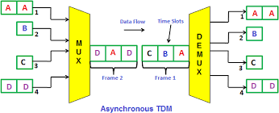  Applications of Time Division Multiplexing | 6

- Used in digital telephone systems.
- Used in cellular communication networks
Winter- 2025 | Unit 2 | Q1c. State any two types of unguided media. Ans.  Radio waves Microwaves Infrared Waves  Q2b. Draw neat sketch of twisted pair cable and state its types. Ans.  A twisted pair cable consists of two insulated copper wires twisted together. The twisting helps in reducing electromagnetic interference (EMI) and crosstalk between adjacent pairs. It is widely used in telephone networks and LANs.  Types of Twisted Pair Cable Unshielded Twisted Pair (UTP)  - No additional shielding around the wire pairs  - Low cost and easy to install  - More susceptible to noise  - Commonly used in LANs (Ethernet)  Shielded Twisted Pair (STP)  - Each pair or entire cable is covered with a metallic shield  - Better protection against noise and interference  - Costlier and difficult to install  - Used in environments with high electromagnetic interference  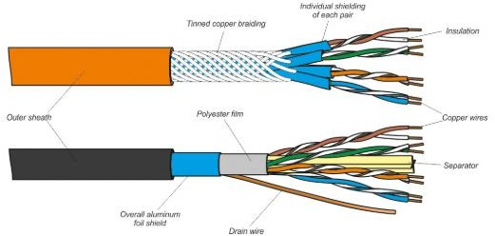  Q4a. Explain satellite communication with neat sketch. – Repeated Question from Summer 2025. | 2  4  4

 |  | Q5a. Explain multiplexing techniques. Ans.  Multiplexing is a technique used in data communication to combine multiple signals from different sources and transmit them over a single communication channel. At the receiving end, the combined signal is separated back into individual signals using a demultiplexer. Multiplexing helps in efficient utilization of bandwidth and reduces transmission cost.  Types of Multiplexing  - Frequency Division Multiplexing (FDM)  In FDM, the available bandwidth of the communication channel is divided into multiple frequency bands. Each signal is transmitted using a different frequency range at the same time. A small gap called a guard band is provided between frequency bands to avoid overlapping and interference.  Features of FDM:  - Signals are transmitted simultaneously  - Used mainly for analog signals  - Requires band-pass filters  - Continuous transmission Examples:  - Radio and television broadcasting  - Cable TV networks  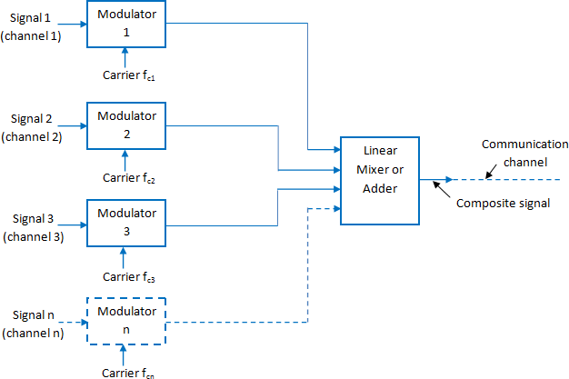  - Time Division Multiplexing (TDM)  In TDM, the entire channel bandwidth is shared by multiple signals in different time slots. Each device transmits data only during its assigned time slot in a repeating sequence.  Types of TDM | 6

 |  | - Synchronous Time Division Multiplexing  In synchronous TDM, each device is assigned a fixed time slot, whether or not it has data to transmit. Time slots are transmitted in a round-robin fashion.  Features:  - Fixed time slots for each sender  - Time slots may remain unused if a device has no data  - Simple to implement  - Requires synchronization between sender and receiver Example:  - Traditional telephone systems  - Asynchronous (Statistical) Time Division Multiplexing  In asynchronous TDM, time slots are assigned dynamically based on data availability. Only active devices are given time slots, which improves channel efficiency.  Features:  - No fixed time slot for each device  - Better bandwidth utilization  - More complex than synchronous TDM  - Requires addressing information Example:  - Computer data networks  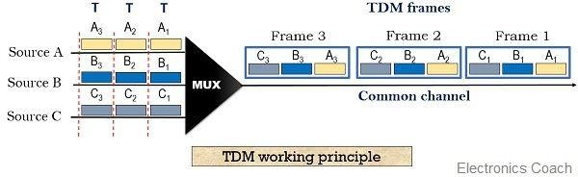  Q6a. Explain packet switching and circuit switching network with diagram. Ans.  In data communication, switching techniques are used to transfer data from source to destination through intermediate nodes. The two commonly used switching techniques are circuit switching and packet switching.  1. Circuit Switching Network  In a circuit switching network, a dedicated communication path is established between the sender and receiver before data | 6

transmission begins. The entire data transfer uses the same path, and the circuit is released after communication ends. Working:
- Connection establishment
- Data transmission
- Connection termination Features:
  - Dedicated path throughout communication
  - Constant bandwidth and low delay
  - Inefficient use of resources when the channel is idle
  - Suitable for continuous data transmission Example:
  - Traditional telephone network (PSTN)

Packet Switching Network
In a packet switching network, data is divided into small packets. Each packet is transmitted independently and may take different paths to reach the destination. Packets are reassembled in correct order at the receiver.
Working:
- Data divided into packets
- Each packet routed independently
- Packets reassembled at destination Features:
  - No dedicated path
  - Efficient use of bandwidth
  - Possible delay and packet loss
  - Supports multiple users simultaneously Example:
  - Internet

 |  | 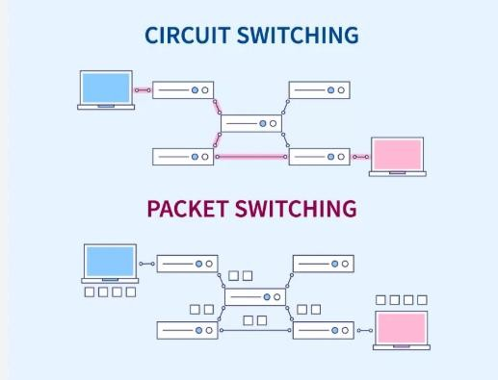
Summe r - 2025 | Unit 3 | Q1d. Define Forward Error Correction (FEC) Technique with neat labelled diagram/sketch. Ans.  Forward Error Correction (FEC) is an error control technique in which the sender adds redundant (extra) bits to the transmitted data so that the receiver can detect and correct errors on its own, without requesting retransmission.  FEC is mainly used in communication systems where retransmission is difficult or time-consuming.  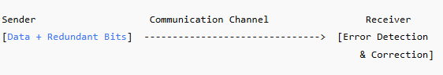  Q2b. Draw and explain bluetooth architecture of piconet.  A piconet is the basic networking unit of Bluetooth architecture. It consists of one master device and up to seven active slave devices communicating using Bluetooth technology within a short range (typically up to 10 meters).  The master device controls the communication by managing timing, frequency hopping, and data transmission. Slave devices can communicate only with the master, not directly with each other. | 2  4

 |  | 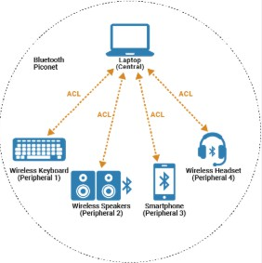  Working of Bluetooth Piconet  - The Master initiates and controls the piconet.  - Slaves follow the master’s instructions for data transmission.  - Communication uses frequency hopping spread spectrum (FHSS) to reduce interference.  - One piconet can have 7 active slaves and additional parked devices.  Features of Piconet  - Short-range wireless communication  - Low power consumption  - Supports point-to-multipoint communication  Applications  - Wireless headphones  - File transfer between mobile devices  - Keyboard and mouse connectivity  Q3b. Explain the Richard W. Hamming Error detection code for Error present in the received data and Error correction code for the Error present in the received data  Ans.  The Hamming code, proposed by Richard W. Hamming, is an error control technique used to detect and correct errors in transmitted data. It is mainly designed to detect and correct single-bit errors in received data.  Hamming code works by adding parity bits at specific positions in the data before transmission.  Working of Hamming Code  1. Error Detection Code  - Parity bits are added to the original data bits at positions that are powers of 2 (1, 2, 4, 8, …).  - Each parity bit checks a specific set of data bits.  - At the receiver, parity bits are recalculated and compared with received parity bits. | 4

- If there is a mismatch, an error is detected.
- Error Correction Code
  - The receiver uses the parity check results to form a binary number called the syndrome.
  - The syndrome value indicates the exact position of the erroneous bit.
  - The receiver corrects the error by flipping the bit at the identified position.
Example (Brief Explanation)
  - Suppose a 4-bit data word is transmitted using Hamming code.
  - 3 parity bits are added to form a 7-bit code word.
  - If a single-bit error occurs during transmission, the receiver calculates the syndrome.
  - The syndrome value gives the position of the error, and the bit is corrected.

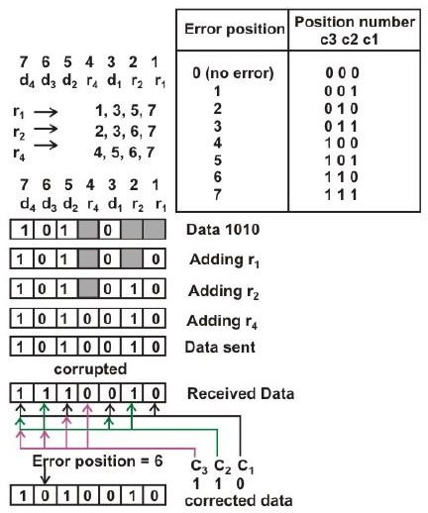

Advantages of Hamming Code
- Detects and corrects single-bit errors.
- No retransmission required.

Limitations of Hamming Code

 |  | - Cannot correct multiple-bit errors.  - Additional overhead due to parity bits.  Q4c. Explain two types of Error in Data transmission with example.  - Single – bit Error  - Burst Error Ans.  Errors in data transmission occur due to noise, interference, or distortion in the communication channel. The two main types of errors are:  - Single-Bit Error  A single-bit error occurs when only one bit in the data unit is changed from 0 to 1 or from 1 to 0 during transmission.  Example:  Transmitted data: 1011001  Received data: 1010001 (Only one bit has changed) Cause:  - Sudden noise spike  - Electrical interference  - Burst Error  A burst error occurs when two or more consecutive bits in a data unit are changed during transmission. The length of the burst error is measured from the first incorrect bit to the last incorrect bit.  Example:  Transmitted data: 1100110011  Received data: 1101001111  (Multiple consecutive bits are affected) Cause:  - Long-duration noise  - Signal attenuation  - Channel distortion | 4

 |  | 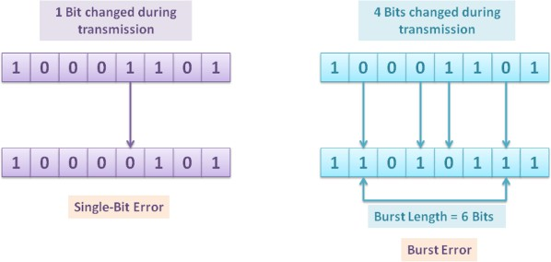  Q6b. Explain three types of ARQ (Automatic Repeat Request) error correction technique for data transmission with neat sketch.  Ans.  Automatic Repeat Request (ARQ) is an error control technique in which the receiver detects errors and requests retransmission of erroneous data from the sender. ARQ ensures reliable data transmission using acknowledgements and timeouts.  Types of ARQ Techniques  1. Stop-and-Wait ARQ  - The sender transmits one data frame at a time.  - After sending a frame, the sender waits for an acknowledgement (ACK) from the receiver.  - If ACK is received, the next frame is sent.  - If a Negative ACK (NACK) or timeout occurs, the frame is retransmitted. | 6

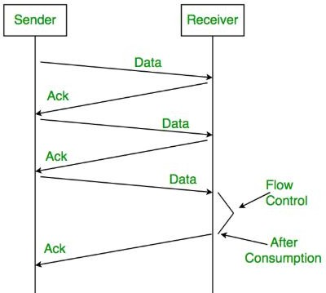
- Go-Back-N ARQ
  - The sender can transmit multiple frames before receiving ACKs.
  - Frames are numbered sequentially.
  - If an error is detected in a frame, the receiver discards that frame and all subsequent frames.
  - The sender retransmits the erroneous frame and all following frames.

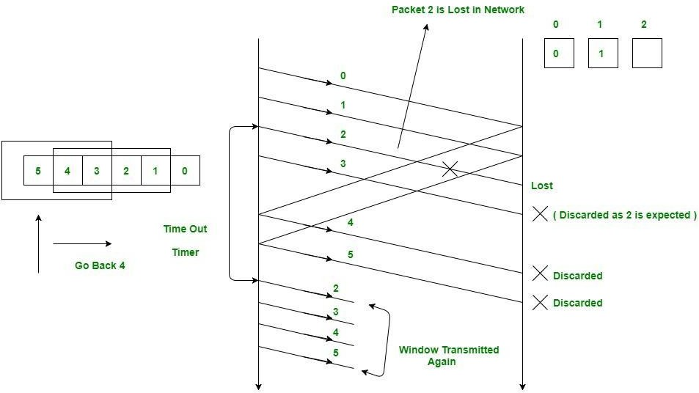
3. Selective Repeat ARQ

- The sender transmits multiple frames.
- Only the erroneous frames are retransmitted.
- Receiver stores correctly received frames and reorders them.
- More efficient but complex.

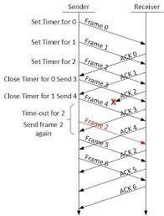

Winter- 2025 | Unit 3 | Q1d. List different types of errors. Ans.  In data communication, errors occur when the received data differs from the transmitted data. The different types of errors are:  - Single-bit Error  - Only one bit in the data unit is changed during transmission.  - Burst Error  - Two or more consecutive bits in the data unit are corrupted.  - It is the most common type of error in data communication.  Q1e. List IEEE 802.X standards for networks. Ans.  The IEEE 802 family defines standards for Local Area Networks (LANs) and Metropolitan Area Networks (MANs). Some important IEEE 802.X standards are:  - IEEE 802.1 – Network architecture, bridging, and network management  - IEEE 802.2 – Logical Link Control (LLC)  - IEEE 802.3 – Ethernet (Wired LAN)  - IEEE 802.4 – Token Bus (obsolete)  - IEEE 802.5 – Token Ring (obsolete)  - IEEE 802.6 – Metropolitan Area Network (MAN)  - IEEE 802.11 – Wireless LAN (Wi-Fi)  - IEEE 802.15 – Wireless Personal Area Network (WPAN – Bluetooth) | 2  2

 |  | - IEEE 802.16 – Broadband Wireless Access (WiMAX)  - IEEE 802.17 – Resilient Packet Ring  Q4c. Explain CRC with suitable example. Ans.  Cyclic Redundancy Check (CRC) is an error detection technique used in data communication to detect errors during data transmission. It treats the data as a binary polynomial and performs division using a predefined generator polynomial.  Working of CRC  - Sender Side  - A generator polynomial G(x) of degree r is selected.  - The original data is appended with r zeros (where r is the degree of G).  - The appended data is divided by the generator polynomial using binary (mod-2) division.  - The remainder obtained is the CRC bits.  - These CRC bits are appended to the original data and transmitted.  - Receiver Side  - The received data (data + CRC bits) is divided by the same generator polynomial.  - If the remainder is zero, the data is accepted as error-free.  - If the remainder is non-zero, an error is detected.  Suitable Example of CRC Given:  - Data = 1101011011  - Generator Polynomial = 10011 (degree = 4) Step 1: Append zeros  Append 4 zeros to the data:  Step 2: Mod-2 Division | 4

 |  | 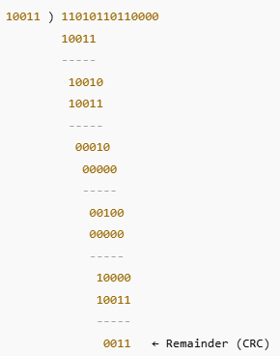  Step 3: Transmitted Data  Step 4: Receiver Check  - Receiver divides 11010110110011 by 10011  - Remainder = 0000  - Hence, no error detected  Q5b. Explain wireless LAN 802.11 architecture. Ans.  IEEE 802.11 defines the standards for Wireless Local Area Networks (WLANs), commonly known as Wi-Fi. The  802.11 architecture specifies how wireless devices communicate with each other and with wired networks.  Main Components of IEEE 802.11 Architecture  - Station (STA)  - Any device with a wireless network interface card.  - Examples: Laptop, smartphone, tablet.  - A station can transmit and receive wireless signals.  - Basic Service Set (BSS)  - The basic building block of a WLAN.  - Consists of two or more stations that can communicate. | 6

- Identified by a BSSID. Types of BSS:
- Infrastructure BSS – Uses an Access Point.
- Independent BSS (IBSS) – No Access Point (Ad-hoc network).

- Access Point (AP)
  - Acts as a central controller in infrastructure mode.
  - Connects wireless stations to the wired LAN.
  - Manages authentication, association, and data transmission.

- Distribution System (DS)
  - A system that connects multiple Access Points.
  - Usually a wired Ethernet network.
  - Allows roaming between different BSSs.

- Extended Service Set (ESS)
  - Formed by two or more BSSs connected through a Distribution System.
  - Provides a larger coverage area.
  - Identified by a common SSID.

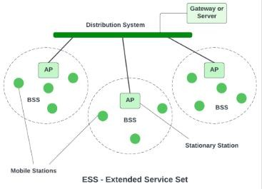

Summer- 2025 | Unit 4 | Q1e. Draw the neat sketch with labels layered Architecture of seven layers of OSI/ISO reference model for Data communication.  Ans.  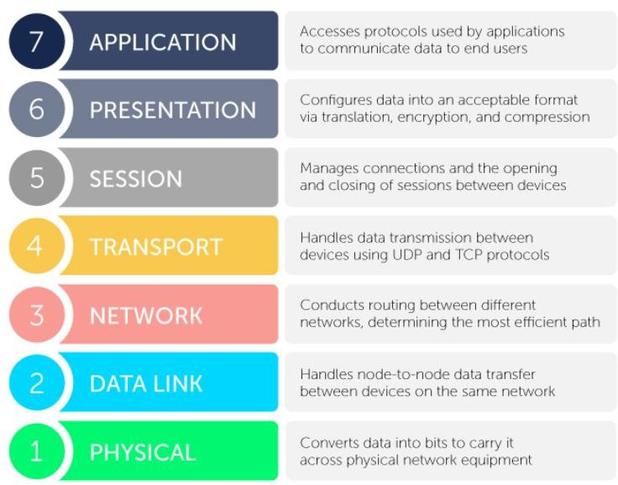  Q1f. Enlist four key FTP standardized commands to facilitate communication between client and server. Ans.  The four key FTP standardized commands used to facilitate communication between client and server are:  - USER – Specifies the username for authentication  - PASS – Specifies the password for authentication  - RETR – Retrieves (downloads) a file from the server  - STOR – Stores (uploads) a file to the server  Q2c. Explain the working of ppp (point to point) protocol.  Point-to-Point Protocol (PPP) is a data link layer protocol used to establish a direct communication link between two nodes over a point-to-point connection. It is commonly used for dial-up connections and direct WAN links.  PPP supports authentication, compression, and error detection, making it more reliable than older protocols like SLIP.  Working of PPP  The working of PPP is divided into three main phases:  - Link Establishment Phase  - PPP uses the Link Control Protocol (LCP) to establish the connection.  - LCP negotiates parameters such as maximum frame size and authentication method.  - The link is tested for reliability.  - Authentication Phase (Optional)  - Authentication is performed using protocols like PAP (Password Authentication Protocol) or CHAP (Challenge Handshake Authentication Protocol). | 2  2  4

 |  | - This ensures secure access between the communicating devices.  - Network Layer Protocol Phase  - After authentication, Network Control Protocol (NCP) configures network layer protocols.  - IP addresses and other parameters are assigned.  - Data transmission begins over the established link.  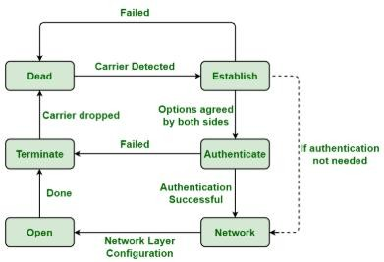  Q2d. State the functions of Internet Protocol (IP) considering below mention functions. Logical Addressing, Packet Routing, Fragmentation, Decapsulation  Ans.  Internet Protocol (IP) is a network layer protocol of the TCP/IP model responsible for logical addressing and delivery of data packets from source to destination across interconnected networks.  - Logical Addressing  IP assigns a unique logical address (IP address) to every device connected to the network. This address identifies:  - Source device (sender)  - Destination device (receiver)  Logical addressing allows devices on different networks to communicate, unlike physical (MAC) addresses which work only within a local network.  Example: IPv4 address – 192.168.1.10  - Packet Routing  IP is responsible for routing data packets through one or more networks to reach the destination.  - Data is divided into packets.  - Each packet contains source and destination IP addresses.  - Routers examine the destination IP address and forward packets to the next best hop. Routing may follow different paths depending on network conditions.  - Fragmentation | 4

 |  | Different networks have different Maximum Transmission Unit (MTU) sizes. If a packet is larger than the MTU:  - IP breaks the packet into smaller fragments.  - Each fragment has its own IP header.  - Fragments are transmitted independently.  - At the destination, fragments are reassembled to form the original packet. This ensures successful transmission across heterogeneous networks.  - Decapsulation  When a packet reaches the destination:  - IP removes (decapsulates) the IP header.  - The remaining data is handed over to the transport layer protocol (TCP or UDP) for further processing. Decapsulation ensures proper layer-wise data delivery in the TCP/IP model.  Q3c. Explain three server methods of Dynamic Host Configuration Protocol (DHCP) of TCP/IP network model for allocating IP – addresses. State two features of DHCP (Dynamic Host Configuration Protocol).  Ans.  Dynamic Host Configuration Protocol (DHCP) is an application layer protocol of the TCP/IP model used to automatically assign IP addresses and other network configuration parameters (such as subnet mask, default gateway, DNS server) to client devices.  Server Methods of DHCP for IP Address Allocation  DHCP allocates IP addresses to clients using the following three server methods:  - Static Allocation (Manual Allocation)  - The network administrator manually assigns a fixed IP address to a specific device.  - The DHCP server maps the IP address to the MAC address of the client.  - The same IP address is always assigned to that device. Use:  Servers, printers, and network devices requiring fixed IP addresses.  - Dynamic Allocation  - The DHCP server assigns IP addresses from a pool for a limited period called a lease time.  - After the lease expires, the IP address may be reassigned to another client if not renewed.  - This is the most commonly used method. Use:  Laptops, mobile devices, and general users.  - Automatic Allocation  - The DHCP server assigns a permanent IP address to a client from the available pool.  - Once assigned, the same IP address is always given to the client.  - No lease renewal is required.  Use:  Small or stable networks. | 4

 |  | Q3d. Explain the following methods of switches for OSI network model i)store – and – forward ii) switching cut – through switching  Ans.  Switches mainly operate at the Data Link Layer (Layer 2) of the OSI model and use different methods to forward frames. The two important switching methods are:  - Store-and-Forward Switching Explanation:  In store-and-forward switching, the switch receives the entire data frame first, stores it in memory, and then checks it for errors using CRC (Cyclic Redundancy Check). Only error-free frames are forwarded to the destination.  Working Steps:  - Entire frame is received by the switch.  - Error checking is performed.  - If no error is found, the frame is forwarded.  - Corrupted frames are discarded. Advantages:  - High reliability  - Error-free data transmission Disadvantages:  - Higher delay due to complete frame storage  - Cut-Through Switching Explanation:  In cut-through switching, the switch starts forwarding the frame as soon as the destination MAC address is read, without waiting for the entire frame to be received. Error checking is not performed.  Working Steps:  - Switch reads destination MAC address.  - Frame is immediately forwarded to the destination port.  - Transmission delay is minimized. Advantages:  - Very low latency  - Faster data transmission Disadvantages:  - Error checking is not performed  - Corrupted frames may be forwarded  Q4d. Explain the structure of IPV6 Address in detail. Ans.  IPv6 (Internet Protocol version 6) is designed to overcome the limitations of IPv4 by providing a much larger address space and improved addressing features. An IPv6 address is 128 bits long and is written in hexadecimal format.  Format of IPv6 Address  - An IPv6 address consists of 8 groups, each of 16 bits. | 4  4

 |  | - Each group is represented by 4 hexadecimal digits.  - Groups are separated by colons (:).  Types of IPv6 Addresses  - Unicast Address  - Identifies a single network interface.  - Packet is delivered to one specific device.  - Multicast Address  - Identifies a group of interfaces.  - Packet is delivered to all members of the group.  - Anycast Address  - Assigned to multiple devices.  - Packet is delivered to the nearest device.  Q4e. Explain two functions of following layer of OSI/ISO Model used for - Session layer, Presentation layer Ans.  - Session Layer (Layer 5)  The Session Layer manages the dialogue and control between two communicating devices. It establishes, maintains, and terminates sessions.  Two main functions:  - Session Establishment, Maintenance, and Termination  - It establishes a session (connection) between applications, maintains it during communication, and terminates it after completion.  - Example: Video call or remote login session.  - Synchronization  - Inserts checkpoints or synchronization points into data streams to recover communication in case of failure.  - Example: If a large file transfer is interrupted, only data after the last checkpoint needs retransmission.  - Presentation Layer (Layer 6)  The Presentation Layer is responsible for data translation, encryption, and compression, ensuring that the data from the application layer of one system can be understood by the application layer of another system.  Two main functions:  - Data Translation / Syntax Conversion  - Converts data from application format to a standard network format and vice versa.  - Example: Converts character encoding (ASCII to EBCDIC).  - Data Encryption and Compression  - Encrypts data for secure transmission and decrypts at the receiver.  - Compresses data to reduce size and increase transmission efficiency.  Q5c. Explain the working of TCP and UDP protocol in the TCP/IP network model with neat labelled diagram. State any two advantages of TCP and UDP protocol.  Ans.  TCP (Transmission Control Protocol) and UDP (User Datagram Protocol) are transport layer protocols in the TCP/IP model. They are responsible for data delivery between applications on the source and destination devices. | 4  6

 |  | - TCP – Transmission Control Protocol Working:  - TCP provides connection-oriented communication, meaning a connection is established before data transfer.  - It segments the data from the application layer into TCP segments.  - TCP ensures reliable delivery using:  - Sequencing – each segment is numbered for correct ordering  - Acknowledgements (ACK) – receiver acknowledges received segments  - Error detection & retransmission – lost or corrupted segments are retransmitted Example: File transfer, email, HTTP/HTTPS  - UDP – User Datagram Protocol Working:  - UDP provides connectionless communication.  - Data is sent as datagrams without establishing a connection.  - No sequencing or acknowledgements, so there is no guarantee of delivery.  - Faster and requires less overhead compared to TCP. Example: Video streaming, online gaming, DNS queries  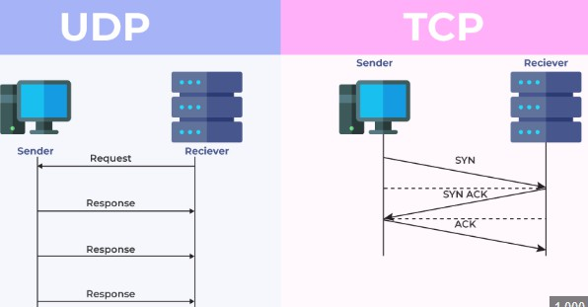  Advantages of TCP  - Reliable data delivery through sequencing and acknowledgements.  - Error detection and correction ensures accurate transmission.  Advantages of UDP  - Faster transmission due to no connection setup or overhead.  - Low latency, suitable for real-time applications.  Q6c. State difference between Peer – to – peer computing model and client – server computing model considering below functions (any six) Type of computing model Type of service Resource sharing Security Performance Reliable | 6

Communication type
Ans.
 |  | Function / Parameter |  | Peer-to-Peer (P2P) |  |  | Client-Server
 |  | i) Type of Computing Model |  | Decentralized – every node acts as both client and server |  |  | Centralized – dedicated server provides services to clients
 |  | ii) Type of Service |  | Distributed – all nodes provide and consume services |  |  | Centralized – server provides services, clients consume only
 |  | iii) Resource Sharing |  | All nodes share resources directly with each other |  |  | Resources managed and shared by server only
 |  | iv) Security |  | Low – security depends on each node individually |  |  | High – centralized control allows better security management
 |  | v) Performance |  | Performance depends on the number of active peers; may degrade with many peers |  |  | High and consistent performance as server is optimized for service
 |  | vi) Reliability |  | Less reliable – if one node fails, its resources are unavailable |  |  | More reliable – server is maintained with redundancy and backups
 |  | vii) Communication Type |  | Direct communication between nodes (peer-to-peer) |  |  | Client communicates with server; server manages responses
Winter- 2025 | Unit 4 | Q1g. List classes of IP addresses.  Ans. |  |  |  |  |  |  |  | 2  4
 |  | Class | Range of First Octet |  | Address Range | Default Subnet Mask |  | Usage
 |  | Class A | 1 – 126 |  | 1.0.0.0 to 126.255.255.255 | 255.0.0.0 |  | Very large networks
 |  | Class B | 128 – 191 |  | 128.0.0.0 to  191.255.255.255 | 255.255.0.0 |  | Medium-sized networks
 |  | Class C | 192 – 223 |  | 192.0.0.0 to  223.255.255.255 | 255.255.255.0 |  | Small networks
 |  | Class D | 224 – 239 |  | 224.0.0.0 to  239.255.255.255 | Not defined |  | Multicast addresses
 |  | Class E | 240 – 255 |  | 240.0.0.0 to  255.255.255.255 | Not defined |  | Experimental / Research
 |  | Q2c. Compare IPv4 and IPv6.

 |  | Parameter | IPv4 | IPv6 |  | 4
 |  | Address Length | 32-bit address | 128-bit address
 |  | Address Space | ~4.3 billion addresses | Very large (2¹²⁸ addresses)
 |  | Address Format | Decimal, dotted notation (e.g., 192.168.1.1) | Hexadecimal, colon-separated (e.g., 2001:db8::1)
 |  | Header Size | Variable (20–60 bytes) | Fixed (40 bytes)
 |  | Address Types | Unicast, Multicast, Broadcast | Unicast, Multicast, Anycast
 |  | Security | IPsec optional | IPsec built-in
 |  | Fragmentation | Performed by sender and routers | Performed only by sender
 |  | Checksum | Header checksum present | No header checksum
Q2d. Draw and explain OSI model.

The OSI model is a 7-layer reference model developed by ISO to standardize communication functions in a network. Each layer performs a specific function, and together they ensure reliable data communication from sender to receiver


- Physical Layer
  - Transmits raw bits (0s and 1s) over the physical medium.
  - Defines cables, connectors, voltage levels, and data rate. Examples: UTP cable, fiber optics, hubs

- Data Link Layer
  - Provides error-free data transfer between two directly connected nodes.

 |  | - Performs framing, error detection, and MAC addressing. Examples: Switches, bridges, Ethernet  - Network Layer  - Handles logical addressing and routing of packets across networks.  - Determines the best path for data delivery. Examples: IP, routers  - Transport Layer  - Ensures end-to-end data delivery between source and destination.  - Provides segmentation, flow control, and error control. Examples: TCP, UDP  - Session Layer  - Establishes, manages, and terminates communication sessions.  - Provides synchronization and checkpoints. Example: Session management in remote login  - Presentation Layer  - Translates data into a common format.  - Performs encryption, decryption, and compression. Example: Data encoding, SSL/TLS  - Application Layer  - Provides network services directly to the user.  - Interface between user applications and the network. Examples: HTTP, FTP, SMTP, DNS  Q3a. Compare OSI and TCP/IP model. Ans. |  |  |  | 4
 |  | Parameter | OSI Model | TCP/IP Model
 |  | Developed By | ISO (International Organization for Standardization) | DARPA / DoD (U.S. Department of Defense)
 |  | Number of Layers | 7 Layers | 4 Layers
 |  | Layer Names | Application, Presentation, Session, Transport, Network, Data Link, Physical | Application, Transport, Internet, Network Access
 |  | Model Type | Reference (theoretical) model | Practical (implementation) model
 |  | Protocol Dependency | Protocol independent | Protocol dependent

 |  | Network Layer Function | Supports both connection-oriented and connectionless services | Supports only connectionless service (IP) |  | 4
 |  | Reliability | Defined at Transport Layer only | Reliability provided by TCP
 |  | Addressing | Logical & Physical addressing defined in different layers | Logical addressing handled by IP
 |  | Usage | Used for learning, design, and troubleshooting | Used in real-world Internet communication
 |  | Layer Separation | Clear distinction between layers | Less strict layer separation
Q3d. List protocols related to all layers of OSI model. Ans.
- Application Layer (Layer 7)
Provides network services directly to the user.
  - HTTP (Hyper Text Transfer Protocol)
  - HTTPS
  - FTP (File Transfer Protocol)
  - SMTP (Simple Mail Transfer Protocol)
  - POP3 (Post Office Protocol)

- Presentation Layer (Layer 6)
Handles data translation, encryption, and compression.
  - SSL / TLS
  - ASCII
  - EBCDIC
  - MPEG
  - JPEG
  - GIF

- Session Layer (Layer 5)
Manages sessions and dialog control.
  - NetBIOS
  - PPTP
  - RPC (Remote Procedure Call)
  - SMB Session Services

- Transport Layer (Layer 4)
Provides end-to-end communication and reliability.
  - TCP (Transmission Control Protocol)
  - UDP (User Datagram Protocol)

- Network Layer (Layer 3)

 |  | Handles logical addressing and routing.  - IP (IPv4 / IPv6)  - ICMP (Internet Control Message Protocol)  - IGMP (Internet Group Management Protocol)  - Data Link Layer (Layer 2)  Provides node-to-node data transfer and framing.  - Ethernet (IEEE 802.3)  - ARP (Address Resolution Protocol)  - RARP  - PPP  - Physical Layer (Layer 1)  Defines physical transmission media and signaling.  - RS-232  - USB  - DSL  - ISDN  Q4d. Differentiate between TCP and UDP. Ans. |  |  |  | 4  6
 |  | Parameter | TCP (Transmission Control Protocol) | UDP (User Datagram Protocol)
 |  | Type of Protocol | Connection-oriented | Connectionless
 |  | Connection Setup | Requires 3-way handshake | No connection setup
 |  | Reliability | Reliable data delivery | Unreliable (best effort)
 |  | Error Control | Error detection and retransmission | Error detection only
 |  | Flow Control | Supported | Not supported
 |  | Congestion Control | Supported | Not supported
 |  | Data Sequencing | Data delivered in correct order | Data may arrive out of order
 |  | Speed | Slower due to overhead | Faster due to low overhead
 |  | Header Size | 20 bytes (minimum) | 8 bytes
 |  | Applications | FTP, HTTP/HTTPS, Email | Video streaming, VoIP, DNS
Q6c. Explain masking, subnetting and supernetting with example. Ans.
In IP networking, masking, subnetting, and supernetting are techniques used to manage IP addresses efficiently.

1) Masking (Subnet Mask)

Masking uses a subnet mask to separate the network portion and host portion of an IP address. The subnet mask works by masking (hiding) the host bits and identifying the network.
Example:
IP Address: 192.168.1.10
Subnet Mask: 255.255.255.0

- Network ID: 192.168.1.0
- Host ID: 10 Use:
To identify whether two devices are on the same network.

- Subnetting
Subnetting is the process of dividing one large network into smaller sub-networks (subnets) by borrowing bits from the host portion.
It improves network performance, security, and efficient IP usage. Example:
Given network: 192.168.1.0/24
Borrow 2 host bits → New subnet mask: /26

Use:
Used by organizations to divide departments into separate networks.

- Supernetting
Supernetting is the process of combining multiple smaller networks into a larger network by reducing network bits. It is also known as route aggregation or CIDR (Classless Inter-Domain Routing).
Example:
Combine these networks:
  - 192.168.0.0/24
  - 192.168.1.0/24

Use:
  - Reduces routing table size
  - Improves routing efficiency on the Internet
Summe r - 2025 | Unit 5 | Q6c. State difference between Peer – to – peer computing model and client – server computing model considering below functions (any six) Type of computing model, Type of service, Resource sharing, Security, Performance, Reliable Communication type  Ans. |  |  |  | 6
 |  | Parameter | TCP (Transmission Control Protocol) | UDP (User Datagram Protocol)
 |  | Type of Protocol | Connection-oriented | Connectionless
 |  | Connection Setup | Requires 3-way handshake | No connection setup

 |  | Reliability | Reliable data delivery | Unreliable (best effort)
 |  | Error Control | Error detection and retransmission | Error detection only
 |  | Flow Control | Supported | Not supported
 |  | Congestion Control | Supported | Not supported
 |  | Data Sequencing | Data delivered in correct order | Data may arrive out of order
 |  | Speed | Slower due to overhead | Faster due to low overhead
 |  | Header Size | 20 bytes (minimum) | 8 bytes
 |  | Applications | FTP, HTTP/HTTPS, Email | Video streaming, VoIP, DNS
Winter  - 2025 | Unit 5 | Q1f. List any four network connecting devices. Ans.  - Hub – Connects multiple devices in a network and broadcasts data to all ports.  - Switch – Connects devices in a LAN and forwards data to the specific destination.  - Router – Connects different networks and routes data packets using IP addresses.  - Bridge – Connects and filters traffic between two LAN segments.  Q3c. Explain –  - STAR topology  - Ring topology with suitable diagram Ans.  Star Topology  In Star topology, all the network devices (nodes) are connected to a central device such as a hub or switch. All data communication passes through this central device.  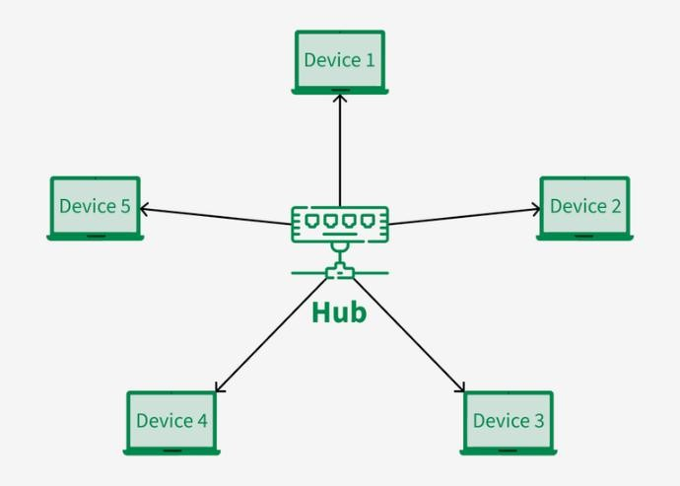 |  |  |  | 2  4

 |  | Advantages:  - Easy to install and manage  - Failure of one node does not affect others Disadvantages:  - Failure of central device breaks the entire network  - Requires more cable length  - Ring Topology  In Ring topology, each device is connected to two other devices, forming a closed loop (ring). Data travels in one direction (or both directions in dual ring).  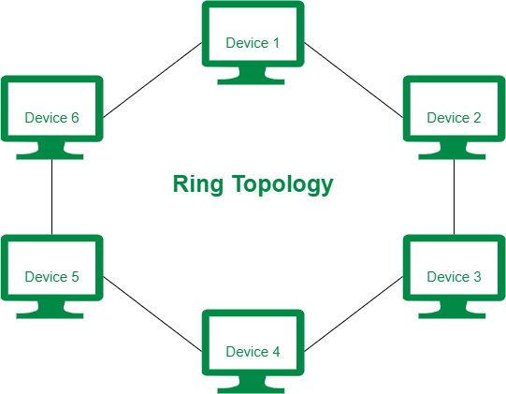  Advantages:  - No data collision  - Equal access to all nodes Disadvantages:  - Failure of one node or link affects the whole network  - Difficult to troubleshoot  Q4e. e) Explain networking devices –  - HUB  - Switch w.r.t layer, port, device type, speed Ans.  - HUB  A Hub is a basic networking device used to connect multiple computers in a LAN. It operates by broadcasting incoming data to all connected ports, regardless of the destination. | 4

 |  | Parameter | HUB
 |  | OSI Layer | Physical Layer (Layer 1)
 |  | Number of Ports | 4, 8, 16, 24 or more
 |  | Device Type | Broadcast device
 |  | Speed | Low (10 Mbps / 100 Mbps)
Features:
- No intelligence or filtering
- Data collisions are common

ii) Switch
A Switch is an intelligent networking device that forwards data only to the intended destination port using MAC addresses.
 |  | Parameter | Switch
 |  | OSI Layer | Data Link Layer (Layer 2) (Some switches work at Layer 3)
 |  | Number of Ports | 8, 16, 24, 48 or more
 |  | Device Type | Unicast device
 |  | Speed | High (10/100/1000 Mbps, 10 Gbps)
Features:
- Reduces collisions
- Improves network performance

